**Geo Location Tracker**

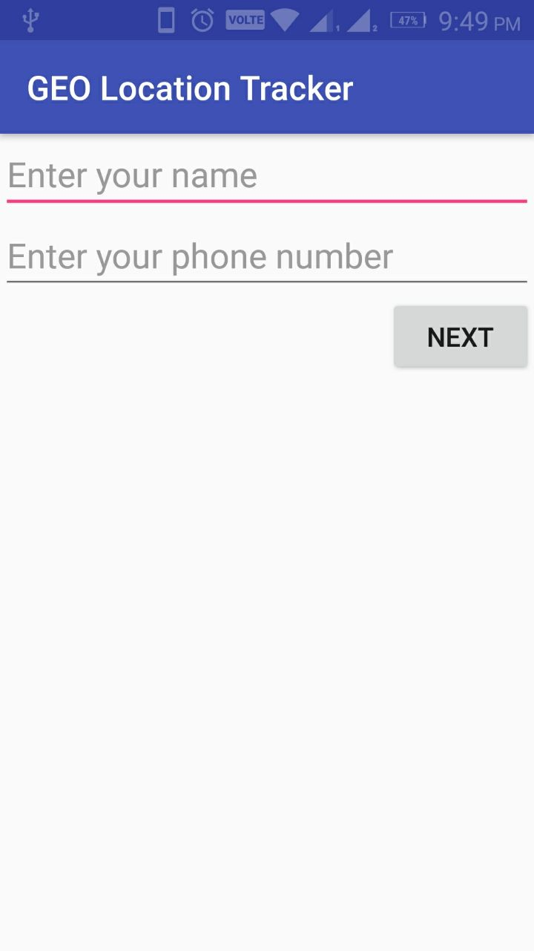

First page of the Application

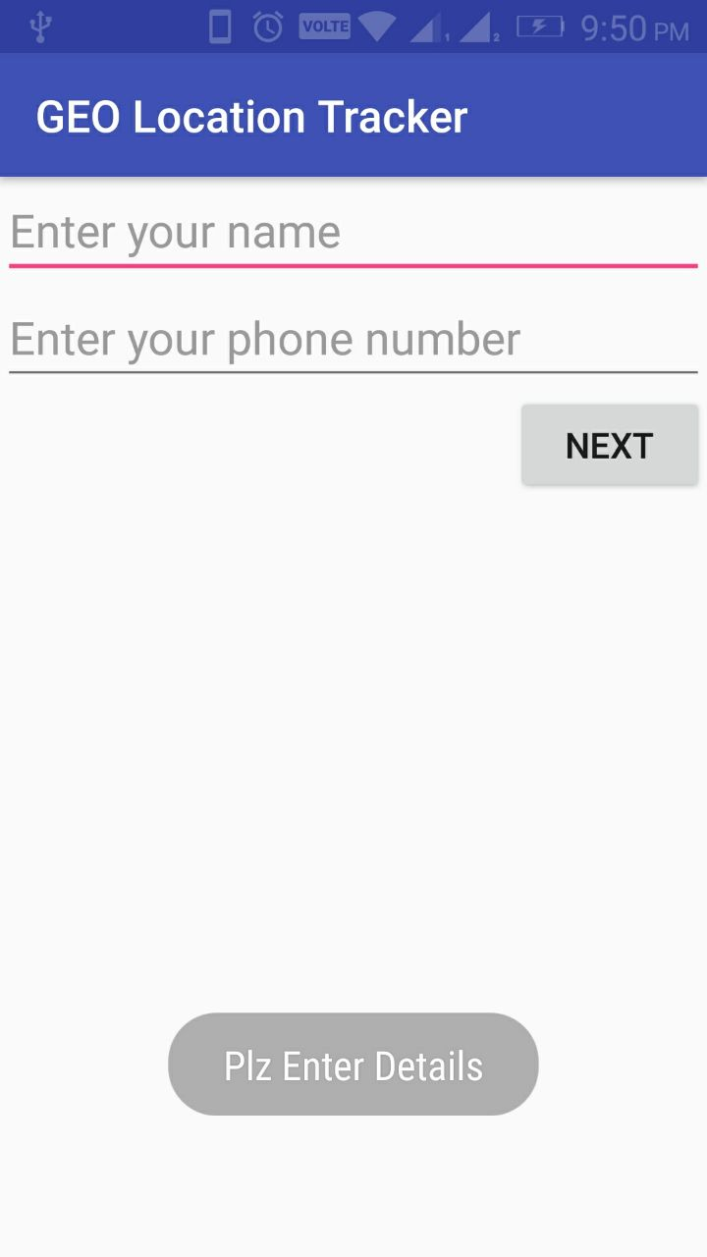

If user clicks on the NEXT button without entering the details then “Plz enter Details” toast will be displayed.

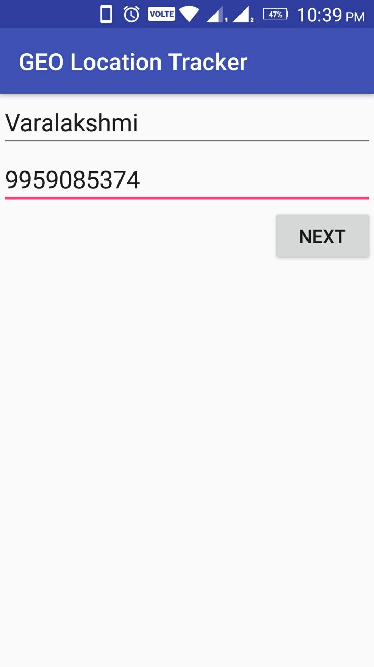

When we click on the next button after entering details, next page i.e., next activity will be performed.

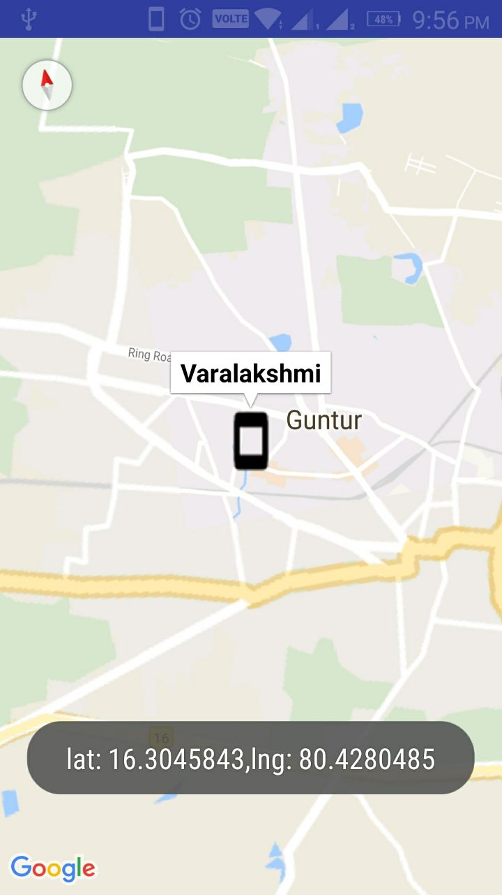

Along with the name of the user location is displayed in second screen.

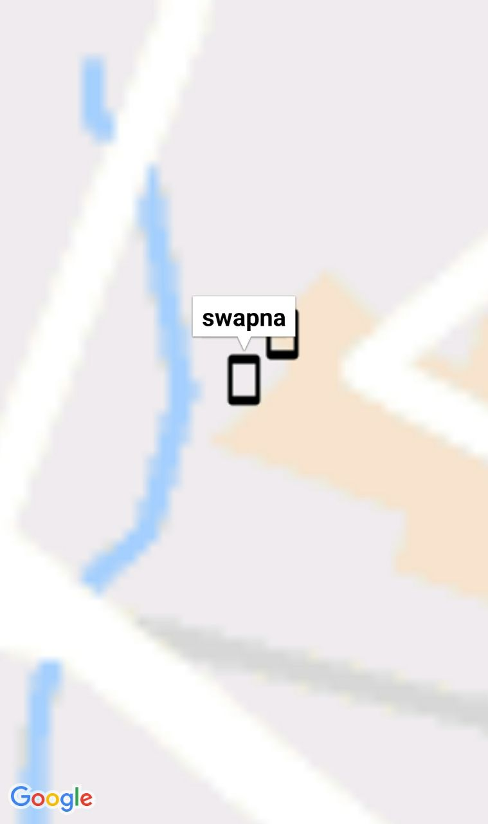

Locating two users

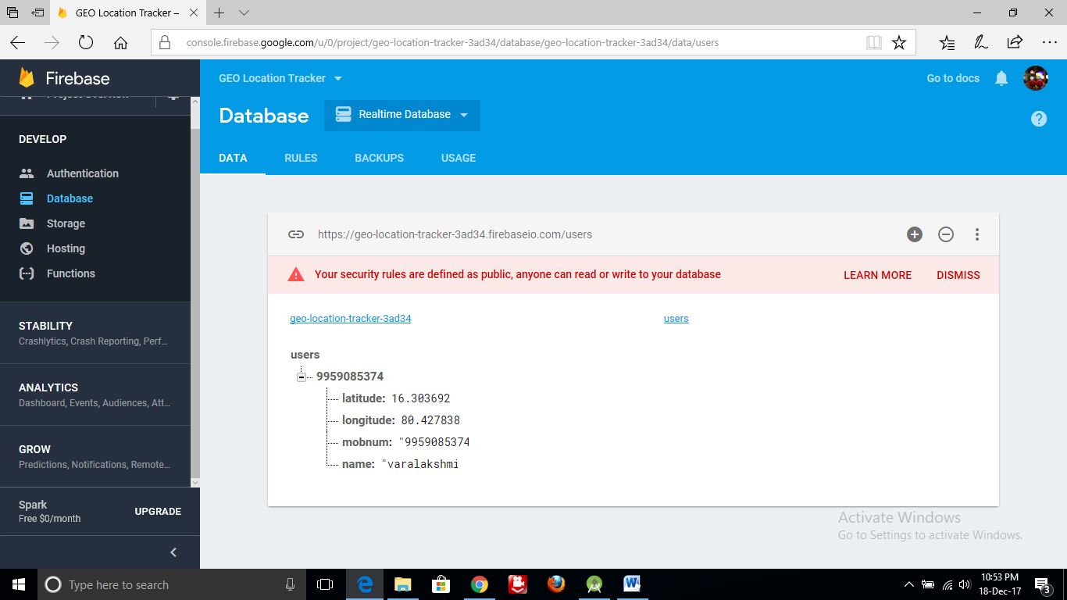

The details which are entered by the user in first page are stored in the database as in the picture.